STEP 1:

TASK; Discuss six questions that you would ask the client giving reasons why each question is important

1. Website goals and strategies – critical for the long term success of your website
2. Design preferences – to know the color schemes, and style of the client
3. Target audience – to know the demographics, preferences, behaviors and goals to create a website that appeals to them
4. Timeline for the project – to plan and finish the project in time
5. What content will be included on the project – to plan the structure and the visual elements
6. Any competitors – to create a design that makes the stand out

HOME PAGE - SKETCH

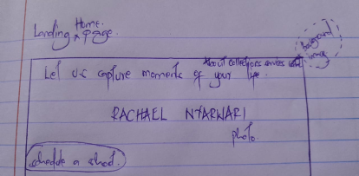

ABOUT PAGE - SKETCH

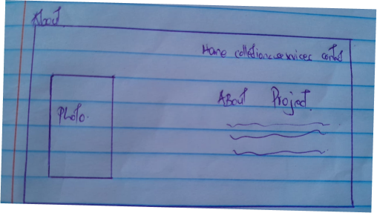

COLLECTIONS - SKETCH

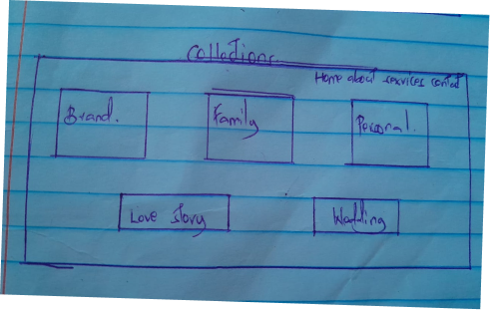

SERVICES - SKETCH

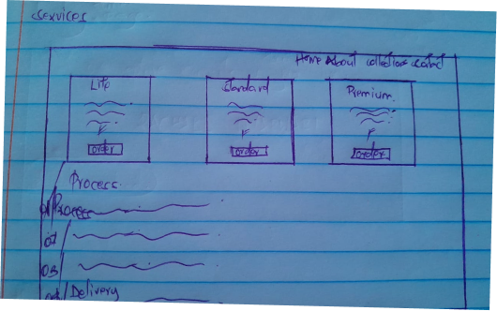

CONTACT PAGE - SKETCH

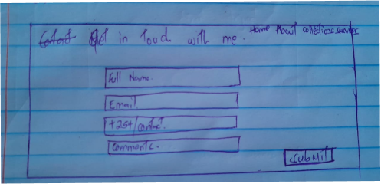

HOME PAGE – WIREFRAME

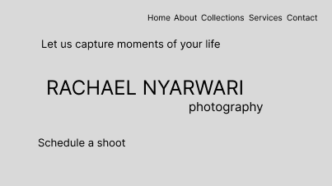

ABOUT PAGE - WIREFRAME

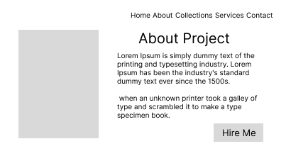

COLLECTIONS - WIREFRAME

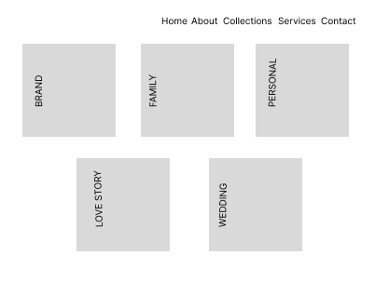

SERVICES –WIREFRAME

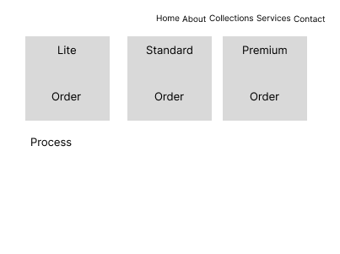

CONTACT PAGE - WIREFRAME

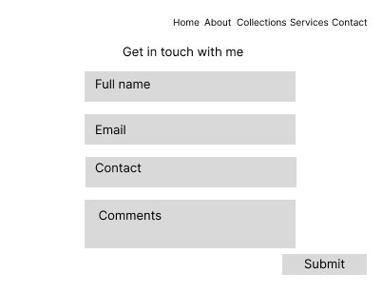

HOME PAGE - MOCKUP



ABOUT PAGE – MOCKUP



COLLECTIONS - MOCKUP

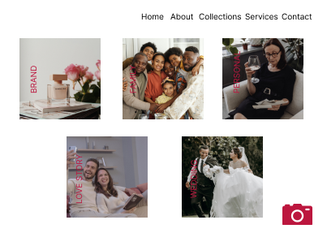

SERVICES - MOCKUP

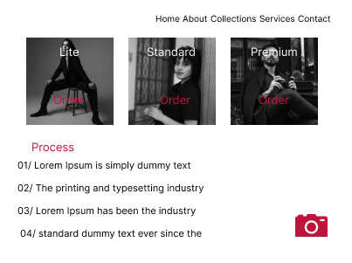

CONTACT PAGE - MOCKUP

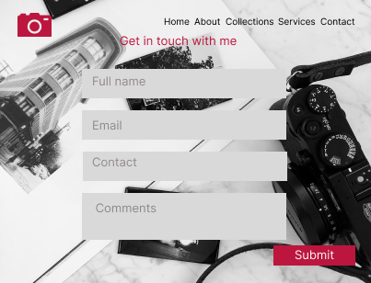

<https://www.figma.com/file/XB8l1ZKkjdwntGwv0dmVcO/Untitled?type=design&node-id=0%3A1&mode=design&t=3pssMNWuHbexhu2x-1>